
AMAN DHAMA
Phone: +91 9999293181
Email: dhama.aman@gmail.com https://in.linkedin.com/in/amandhama12

An enthusiastic & high energy driven professional, targeting assignments in Marketing, Digital Marketing, Brand Management, Business Analysis & Market Research preferably in Delhi NCR, Pune & Bengaluru
Core Competencies

Marketing & Brand Strategy
Business Development
Product & Brand Launches
Media Planning/Engagement
Digital & Social Media Marketing
Marketing Campaign/Promotion
Certifications

- Completed the following certification course:
- Financial Analysis Prodegree from Imarticus in collaboration with EY
- MS Office (Word/ Excel/ PowerPoint)

 | Profile Summary
- A competent professional with nearly 2.5 years of experience in marketing & brand management; assisting in growing and managing professional associates and client relationships
- Gained international exposure in project management during execution of academic project titled Degree Program International Exchange/Tornio, Business in 2016 at Lapland University of Applied Sciences-School of Business and Culture, Tornio, Finland
- Excellence in developing and implementing innovative advertising and marketing strategies that increase product awareness, customer acquisition & retention, market share, penetration and revenue
- Leveraged market research, industry analysis, and customer insights to anticipate and counter competitive actions, build customer loyalty, and position brand for enhanced market share
- An effective communicator with excellent relationship building & interpersonal skills; strong analytical, problem solving & organizational capabilities

Academic Details

- Post Graduate Diploma in Management from IILM Graduate School of Management, Greater Noida in 2017
- Bachelor of Business Administration from Manav Bharti University, Solan, HP in 2013 with 71%
- 12th from Tali Muddin Intercollege, Mau, UP in 2010 with 61%
- 10th from Army Public School, Bareilly, UP in 2007 with 62.2%

Soft Skills | Career Timeline
  Decision- Maker  Motivator  Thinker  Collaborator  Communicator  Planner |     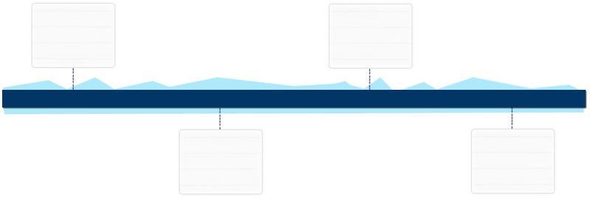  Big Basket, Noida as a Business Development Manager  ASP Media & Inforteainment Pvt. Ltd., Noida as Marketing Manager  Oct’16 – Oct’18  Nov’18 – Till Date
Organizational Experience

Nov’18- Till Date with Big Basket.Com, Noida as Business Development Manager

Key Result Areas:
- Developing strong market knowledge of existing and potential clients and ensuring business growth opportunities aligned to company’s strategic plans
- Providing in-depth analysis of markets, industry trends, competitors and clients to improve strategic planning and decision making
- Identifying the expectations of the prospective clients, by obtaining relevant in-depth information on future projects, bids / Request for Quotation (RFQs) and designing commercial proposals specific to each client
- Pipelining sales based on market research, network management and client references; planning and preparing approaches, pitches and proposals, participating in pricing and work order negotiations
- Standardizing brand identity by implementing branding guidelines on design tools used in creating and disseminating company communication (typefaces and styles, color palette, relevant images, text, tone, and the emotion portrayed by the brand)
- Mapping business needs and tailoring a solution using all relevant products and solutions, drawing on expert internal resources as required

Highlights:
- Managed a team of 8 People
- Achieved the predefined business targets & contributed in generation of revenue and expanding the market
- Performed BTL activities for client acquisition & revenue generation

Previous Experience

Oct’16-Oct’18 with ASP Media and Inforteainment Pvt. Ltd., Noida as Marketing Manager

Key Result Areas:
- Conducted brand-positioning research to ensure that the brand's communications are built on a relevant and differentiating foundation that gains an emotionally compelling place in the consumer's mind
- Crafted marketing messages consistent with the organization’s vision, mission and value statements
- Ensured adherence to brand and corporate messaging guidelines across the company’s websites and print & electronic publications
- Organized company events including workshops, trainings, seminars and annual sales summits; planned & coordinated the corporate functions & simultaneously helped in designing & delivering marketing material displayed at the events
- Managed & updated various websites with information regarding new products, events, and so on
- Worked on a new advertising campaign that helps to enhance the brand image; communicating noticeable product benefit and augmenting sales in the test market

Internship

Organization: OM Logistics Ltd., New Delhi
Period: May’16-Jul’16
Designation: Marketing Trainee
Roles:
- Identified & approached new clients for the company; offered various services to the new companies; developed new market for the company

Technical Skill

- MS Office (Word, PowerPoint & Excel)

Personal Details

Date of Birth: 12th September 1991
Languages Known: English & Hindi
Address: C-121, Gulshan Homz Vivante, Plot-7A, Sector-137, Noida-201301

(Please Refer to project annexure for Project details)

Project Annexure

Academic Projects

Project Title: Detailed Study of Wipro Group & Coca Cola regarding the Product & Performance Management System and Employee Satisfaction
Key Learnings:
- Conducted analysis on company’ performance management and its cycle
- Studied 360-degree performance appraisal
- Analyzed the performance management stages of Coca Cola & Wipro Group
- Understood the advantages of performance management system

Project Title: Field Course Project on “Problem in Agriculture Marketing”
Key Learnings:
- Conducted study to identify the factors affecting the farmers growth
- Understood the undue advantages of farmers
- Studied the problem and provided solution to rectify the same

Project Title: Degree Program International Exchange/Tornio, Business
(Lapland University of Applied Sciences-School of Business and Culture)
Tornio, Finland 2016
Key Learning:
- Incorporated innovation through collaborative team project work

